Calculating Detection Signal of Different Methods for a Jupiter-like Planet around a Sun-like Star.

M. Berger, A. Bernhardt, M. Bleich, Y. Shi, A. Tarrant

**1. Introduction/Motivation**

The search for exoplanets is a direct extension of humankind’s longest-lasting question, *what else is out there?* In this paper, we analyze the ability of state-of-the-art technology to answer this question based on the current limitations of our instruments. In Section 2, we examine three primary detection methods, radial velocity (2.1), transit photometry (2.2), and direct imaging (2.3) and calculate the sensitivity of their detection capabilities to understand each of their constraints. We then compare these limits on plots depicting various planet properties, which exhibit how our current technological capacities influence the known planet population in our galaxy. In Section 3, we apply these calculations to test the potential of discovering a Jupiter-like planet around a Sun-like star. However, it is important to recognize that different detection methods survey different planet parameters; therefore, a detection alone does not convey much information and must be followed up using other methods. Finally, we conclude that we are able to detect a Jupiter-like planet around a Sun-like star in exosolar systems using the radial velocity method.

**2. Methods**

In this section, we examine the limitations on our ability to detect exoplanets using three methods: radial velocity, transit photometry, and direct imaging. We use established mathematical relationships to solve for the detection signals using each method, which will be used to calculate our ability to detect a Jupiter-like planet in the next section.

2.1 Radial Velocity

The radial velocity detection method records light emitted from stars to calculate the “wobble” which a star experiences from the gravitational effects of the star-planet system using the Doppler effect. The R.V. amplitude, K, is the limitation which determines whether a planet is detected. Current technology can detect an R.V. amplitude of about *K*=0.5 m/s, where

$$K=(\frac{M_{p}}{M_{*}})\sqrt{\frac{GM_{*}}{a}}sin(i)$$

Here, we use values from our solar system including Jupiter’s mass ( $1.898×{10}^{27}$ kg) for $M_{p}$, our Sun’s mass ( $1.989×{10}^{30}$ kg) for $M_{*}$, and Jupiter’s semi-major axis (778.479 $×{10}^{6}$ km). Furthermore, G is the gravitational constant, and we assume an inclination of 90° so that sin(*i*)=1 to maximize this value.

2.2 Transit Photometry

The transit photometry method involves surveying the light from stars to analyze when part of the light is blocked by an orbiting planet passing between its parent star and Earth. In this calculation, we use the relationship given by Kepler’s third law, which relates a planet’s orbital period, *T*, to its semi-major axis, where

$$T^{2}=\frac{4π^{2}}{GM}a^{3}$$

This method requires a near edge-on inclination to capture a transit. Here, we calculate the probability of detecting a planet $P_{transit}$, where

$$P_{transit}=\frac{R_{*}+R_{p}}{a}$$

In this calculation, we use the radius of Jupiter (69911.5 km) and the Sun (696347 km) for $R_{P}$ and $R_{*}$, respectively, and we assume a semi-major axis equal to our Jupiter’s. In this case, the fraction of light blocked is given by

$$f={(\frac{R_{P}}{R_{*}})}^{2}$$

2.3 Direct Imaging

This detection method is—as its name suggests—the most direct, as it is like taking a snapshot in time of the exoplanet. However, many challenges arise in observing the planet’s presence, as planets orbit relatively close to their parent star, which is much brighter and can overpower the planet’s signal. Therefore, this light must be blocked, and the planet’s reflection and thermal emission must be large enough that we can differentiate the planet from the star. The light measured, *f*, is found by combining the black body emission of the planet and the reflected starlight, where

$$f=f_{reflected}+f_{emitted}$$

The $f_{reflected}$ term is given by

$$f_{reflected}=\frac{{{πR}_{p}}^{2}}{4πa^{2}}A$$

We assume an albedo value of 1 to maximize this term, and we use our Jupiter’s mass and radius once again. Furthermore, the $f_{emitted}$ term is found from the Planck function:

$$B_{v}\left(T\right)=\frac{2hv^{3}}{c^{2}(e^{\frac{hv}{kT}}-1)}$$

which describes the specific intensity of the parent star. From this, we can derive the star-planet contrast, where

$$f_{emitted}={\left(\frac{R_{p}}{R_{*}}\right)}^{2}\left(\frac{\exp\left(\frac{hc}{{λk}_{B}T_{*}}\right)-1}{\exp\left(\frac{hc}{{λk}_{B}T}\right)-1}\right)$$

The total light is the sum of these terms, where

$$f_{total}={\left(\frac{R_{p}}{R_{*}}\right)}^{2}\left(\frac{\exp\left(\frac{hc}{{λk}_{B}T_{*}}\right)-1}{\exp\left(\frac{hc}{{λk}_{B}T}\right)-1}\right)+\frac{{R_{p}}^{2}}{4a^{2}}$$

Once again, we use the planetary and stellar masses from our solar system. Additionally, $T_{*}$ is the temperature of the sun (5772 K), $T_{P}$ is the temperature of Jupiter (130 K), and $k_{B}$ is the Boltzmann constant. We replace v in the Planck function with *hc*/ $λ$, as we will use the Rayleigh limit as a basis for differentiating between stellar and planetary emission. This allows us to calculate the minimum angular separation, $θ$, where

$$θ=1.22\frac{λ}{D}$$

In this equation, $λ$ is the observation wavelength and D is the diameter of the telescope. To successfully determine the minimum angular separation for a Jupiter-like planet, the peak wavelength $λ_{peak}$ is calculated, where

$$λ_{peak}=\frac{2900 K*μm}{T_{P}}$$

and 2900 K*mm is a constant. Due to this involving a Jupiter-like planet, the temperature of Jupiter is used again to determine this peak wavelength. In this case, $λ_{peak}=λ$ will be used for the star-planet contrast and minimum angular separation equations.

**3. Results**

For the radial velocity method, we calculated a K value of 12.46 m/s, which is about 25 times larger than the lower limit of the detection signal. This means we are likely to find a planet as massive as Jupiter from its gravitational effect on the star. Additionally, the minimum mass of a planet which we could detect assuming a K value of 0.5 m/s is about 76 $×{10}^{24}$ kg, or about 4% of our Jupiter’s mass.

When calculating the geometric probability of detecting a transiting Jupiter-like planet, we found a very low chance at about a .01%. This means it is about 5 times more likely to find an Earth-like planet transiting. This is due to the planet’s semi-major axis, for which Jupiter’s is about 5 times larger than Earth’s, as there is a negative correlation between a planet’s semi-major axis and the geometric probability of being detecting while transiting. Furthermore, Jovian type planets with a>1.6 AU require a significance of 400 SNR (signal to noise ratio) to be detected due to their long orbital periods (Gould).

For direct imaging, we first calculated an appropriate observable wavelength of 22.31 𝜇m

for an exoplanet that features a Jupiter-like temperature. For our computation, we chose the JWST (James Webb Space Telescope) which has an optimal wavelength range from 5-27 𝜇m

with a diameter of 6.5 m (Seager, Direct Imaging of Exoplanets, Section 5, Table 9), resulting in a minimum angular separation of 0.8637’’ or 1.157 parsec. When determining the star-planet contrast, we calculated a value of 8.367 $×{10}^{6}$. Contrast limits at 1’’ for the MIRI instrument in JWST, which operates between 5-28 𝜇m, is predicted to approach ${10}^{-4}$ (Beichman et al., 2020). Since our calculated star-planet contrast is less than the MIRI limit, we can establish that direct imaging would not be able to detect a Jupiter-like planet around a Sun-like star.

For each detection method, our calculations are in agreement with the known planet populations from NASA’s Exoplanet Archive. In Figure 1, we display four plots depicting relationships between the planet parameters discussed including mass, radius, semi-major axis, and orbital period. The first two plots show that Jupiter’s mass is clearly above the sensitivity line for the radial velocity method, which we have confirmed, and that detections using direct imaging are not possible. Although Jupiter’s radius places it above the limit for the transit method, our calculation that the probability is low holds based on its orbital period. Furthermore, it is clear that our calculated sensitivities fall below the bulk of the planets detected with each method, confirming their validity.

**4. Conclusions**

It is possible to detect a Jupiter-like planet around a Sun-like star using the radial velocity method. The large planetary mass ensures an amplitude which we can measure using current technology. However, due to Jupiter’s distance from the sun, it is difficult to detect similar planets using the transit photometry or direct imaging method. A transit detection is technically possible because of the planet’s large radius−which would block 1% of the light from a Sun-like star− but is extremely unlikely because of its semi-major axis which causes a lengthy orbital period. Furthermore, its distance from the star provides for a cool planet, which is difficult to detect using direct imaging; even though the starlight would not block the planet’s signal, there is not enough black body emission for the planet itself to be detected. Our results are confirmed in their strong graphical agreement with the known planets from NASA’s Exoplanet Archive (Figure 1). The primary problem in detecting Jupiter-like planets is the distance from its parent star; in future missions, using a long survey period would increase the chance of catching a transit during the planet’s orbit, and advancing technology which can detect cooler planets would be necessary to detect a planet through direct imaging. From these results, we would be able to calculate the mass of a newly detected planet, but it would be difficult to confirm its other properties.

**5. Contributions**

Yuanhao wrote the necessary code and produced the plots with radical velocity and imaging detection limits. Missy made the transit limits on the plots. Alex researched the state-of-the-art technology and calculated the detection limits for our scenario. Ashley wrote the written report, with help from Alex on the direct imaging method. Mariana created the presentation slides.

**References**

Beichman, C., Barrado, D., Belikov, R., Biller, B., Boccaletti, A., Burrows, A., ... & Ygouf, M. (2019). Direct imaging and spectroscopy of exoplanets with the James Webb Space Telescope. Bulletin of the American Astronomical Society, 51(3), 58.​

Williams, D. (2016). Planetary fact sheets. NASA. Retrieved February 2, 2022, from https://nssdc.gsfc.nasa.gov/planetary/planetfact.html ​

NASA. (n.d.). Key facts - webb/NASA. NASA. Retrieved February 2, 2022, from <https://webb.nasa.gov/content/about/faqs/facts.html>​

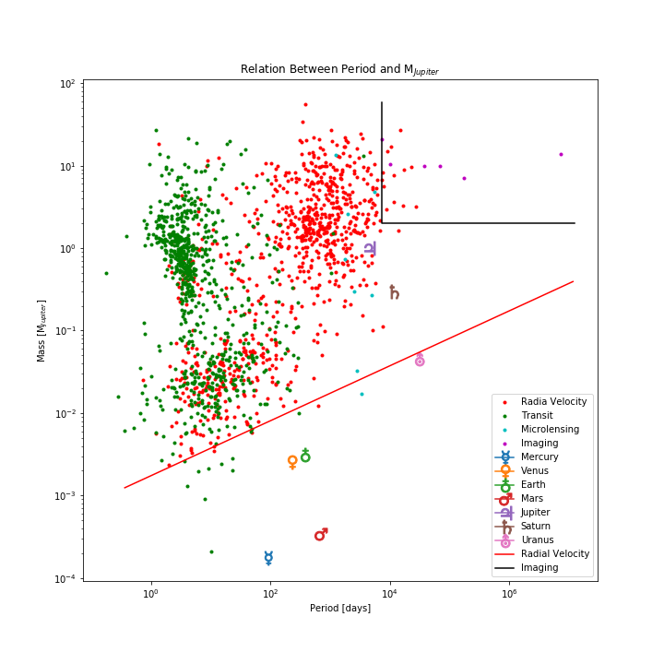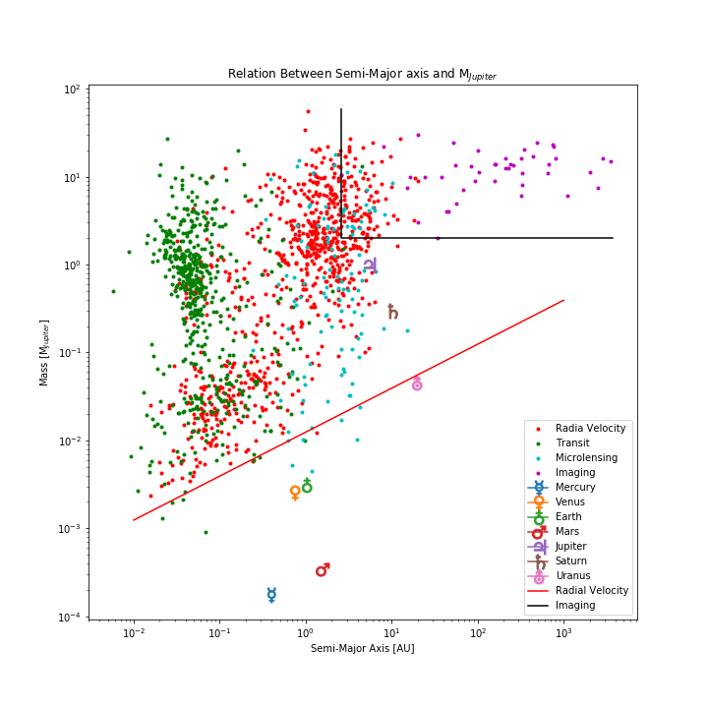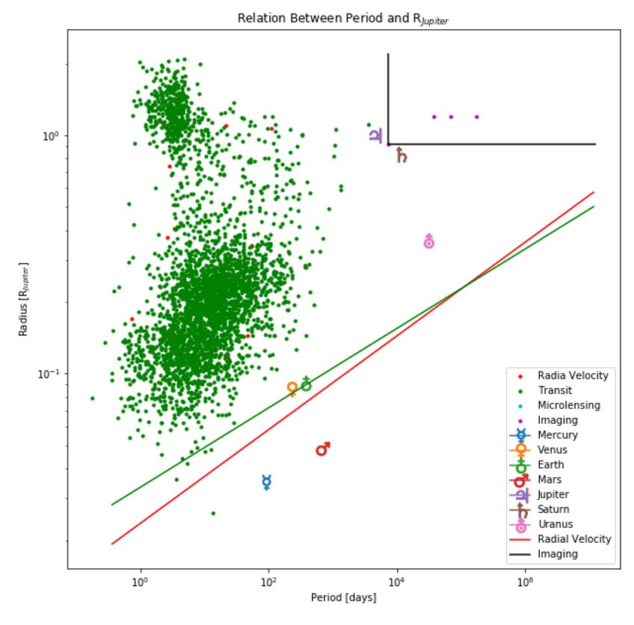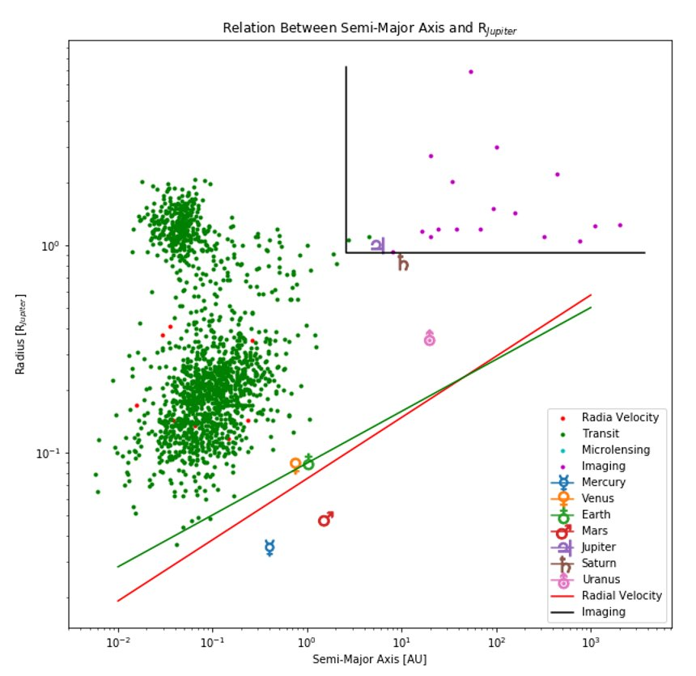

Figure 1: plots depicting various planet parameter relationships with data from NASA’s Exoplanet Archive. Planets discovered plotted in different colors corresponding to their initial detection method. The sensitivity lines represent the detection limits for each of the different methods described. *Note: green line represents transit photometry limit